Digital Design Report

4 bit ALU

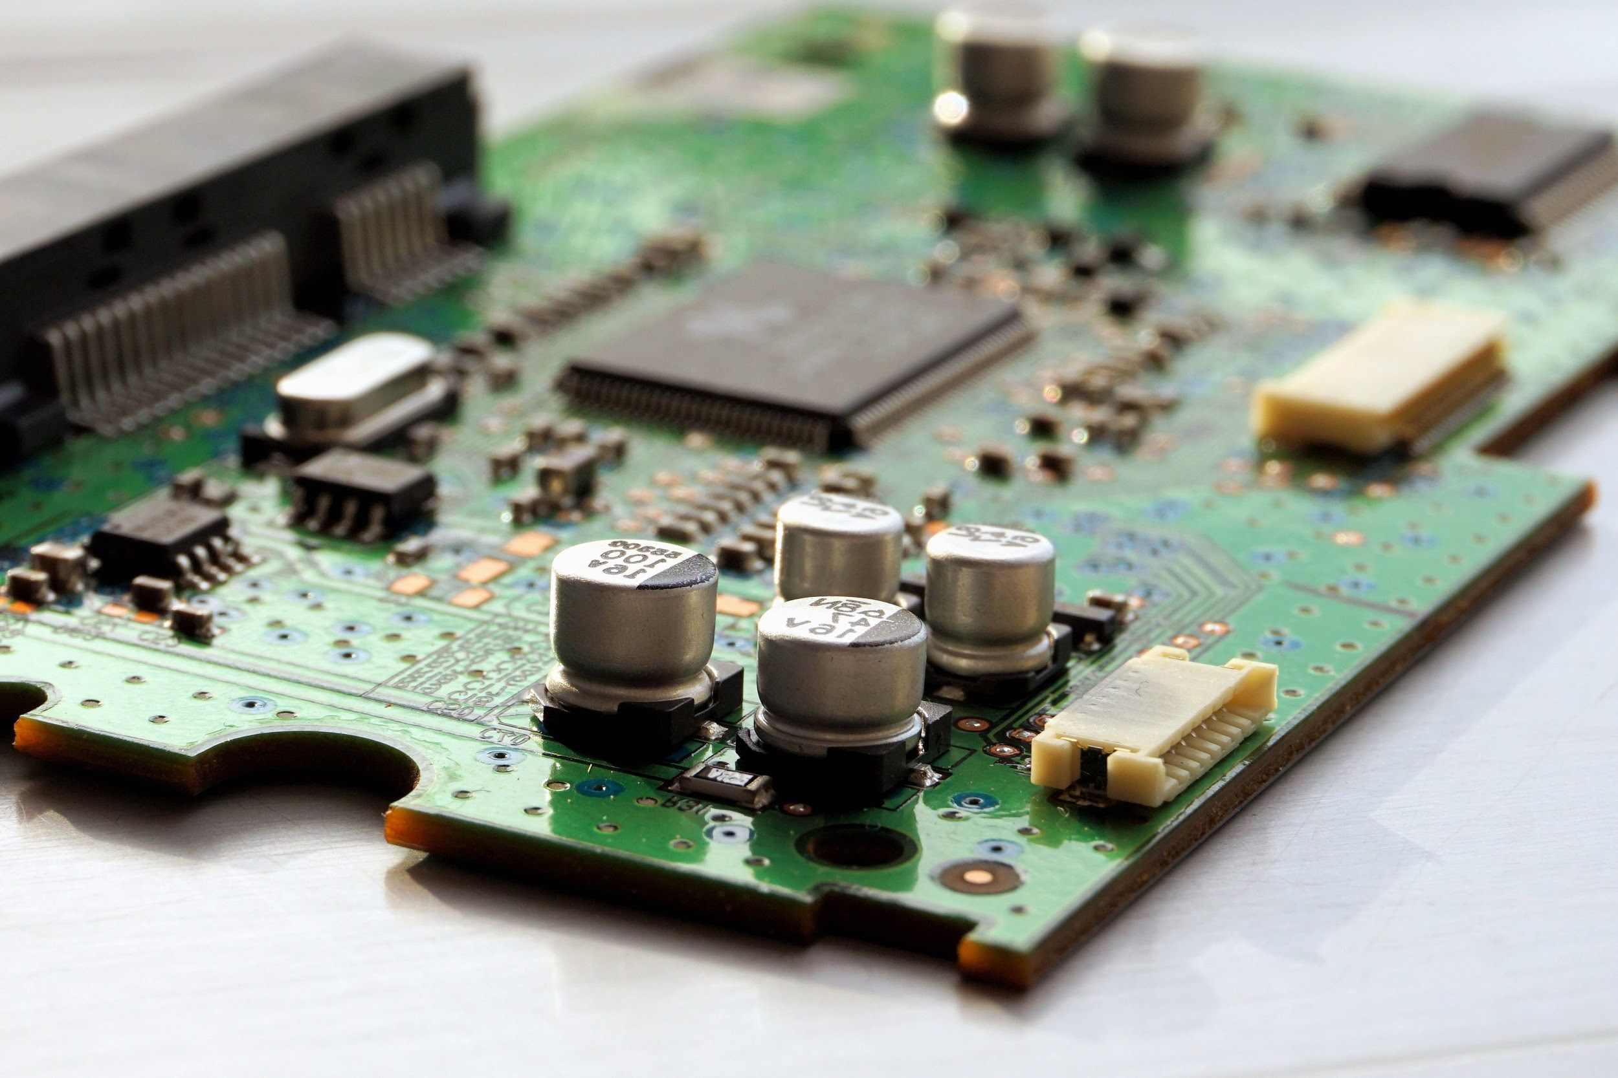

**AbdelSalam ElTamawy**

**Sara Ahmed**

03.09.2019

Digital Design 1

# Contributions To The Project

Both team members worked tirelessly to make this project a success. We started out by meeting up to brainstorm the circuit. We then ultimately decided that AbdelSalam would complete the schematic diagram, while Sara was to work on the block design. Both designs were done on Logisim. Once that was completed, and confirmed, AbdelSalam took it upon himself to buy the equipment for the project, and we met up to complete it on Wednesday the 27th, and Thursday the 28th.

# 

# Block Diagram

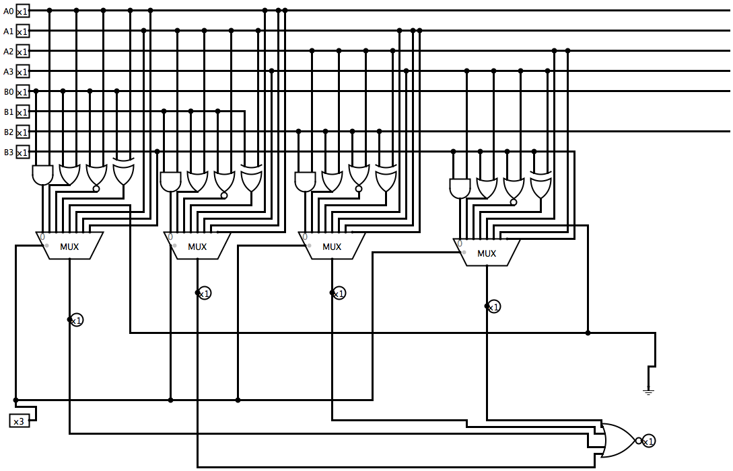

# Schematic Diagram

